Want to go into more groundwater chemistry. What are controls (short term geochemical) . Long term (flow)
How do microbes play into it

Initial Exploratory Data Analysis Using Power BI
The figures in Section 9.3, Appendix show the greatest degree for arsenic of its variable, filtered for aquifer group 1 (AG1). The wells that were above the Canadian drinking water standards were turbid, more than those of sea water intrusion. However, the well samples did not have much chloride or specific conductance. Those samples all had high alkalinity (>150 mg/L)(Health Canada, 2015) but did not exhibit high levels of chloride, sulfate, or nitrogen. The graphs for power BI show no specific pattern and incomplete data therefore as a result the metal was discontinued for further analysis.
As a background, inorganic arsenic is in groundwater in two oxidation states: arsenite (As⁺³) and arsenate (As⁺⁵) with the geological environment favoriting one form over another (Shankar et al., 2014). Both forms exist at pH 6-9. While arsenate is favored thermodynamically in oxic water while arsenite is favored in anoxic, water with both states have been reported.
The release and mobility of As in groundwater is related to both Fe and Al oxides in sediments along with indigenous metal reducing bacteria in anoxic conditions (Shankar et al., 2014). This relationship was not seen due to the large spatial area of British Columbia. As leaches from iron minerals in oxic and high pH (Kanel et al., 2023). Low hydraulic gradients aquifers with higher residence time lead to more dissolved arsenic (Kanel et al., 2023). The majority of geogenic As comes from recently deposited alluvial sediments. Arsenic bearing sulfide minerals from geothermal deposits may also release As into water via oxidation. A relatively diverse amount of micro-organism have been discovered to utilize arsenic for energy generation via arsenite oxidation and arsenate reduction. These processes are reported to occur simultaneously with geochemical processes and observed to have an effect on As speciation (Kanel et al., 2023; Liao et al., 2011). The primary microbial processes for arsenic transformation/mobilization are methylation, demethylation, oxidation, and reduction and are often tied to iron. Given the lack of iron patterns, this could indicate that geochemical controls may be more dominant then microbial ones.
Four possible ways of subsurface arsenic mobilization have been proposed by Oremland and Strolz: 1) As oxidation in pyrites, 2) iron oxide reduction leading to the release of As(V) via present allochthonous (indigenous) organic matter , 3) iron oxide reduction leading to the release of As(V) via present autochthonous (displaced) organic matter and 4) displacement of As(V) via phosphate (such as fertilizers) (Oremland & Stolz, 2003). Given the high turbidity with As over CWDS limits and assuming it is geogenic in nature, it’s likely that the sources were either 2) or 3) which could coincide with areas in B.C. with high groundwater arsenic such as the Lower Fraser Valley (Wilson et al., 2008). Otherwise, it could be due to previous mining runoffs.
B.C.’s alkalinity is predominantly a function of geology (Raudsepp et al., 2024). While northeastern B.C tends to have higher alkalinity over 200 mg/L due to carbonate rich bedrock such as limestone and dolostone while groundwater interacting with volcanic rocks in southwestern B.C. is far lower (Earle, 2019). Localised natural dissolution of carbonate minerals without other major ions that influence specific conductance could explain the gap between alkalinity and specific conductance (Arciszewski & Roberts, 2022).
Alkalinity represents the buffering capacity of alkalinity and buffers the water to the range which promotes arsenic dissolution (Shankar et al., 2014). The more feasibly the common aquifer geology contains carbonate rich aquifer mineralogy that is conductive to arsenic release under more alkaline reducing conditions (Health Canada, 2015; Mushtaq et al., 2018). Possible past flow paths might additionally have transported arsenic rich waters with alkalinity, which over time was isolated from other ionic sources (Yang et al., 2015). Further research should view the relative ratios of chloride, sulfate and bromide to match that of seawater to analyse the effect of saltwater intrusion vs rock water interactions (Saberimehr et al., 2017).
Manganese over the CWDS of 0.02 mg/L against other factors are shown in Section 9.3, Appendix (Health Canada, 2015). In aquifer group 1, manganese levels all had high iron levels, low phosphorus levels and high levels of water hardness. Furthermore, these levels had low turbidity and moderate specific conductance that was not at the cut off for seawater intrusion.
The geochemistry of Mn and Fe in groundwater is closely linked due to both existing in various redox states with groundwater chemistry microbially mediated****. Low reducing conditions indicate soluble Mn+² and Fe⁺², while Mn⁺⁴/Fe⁺³ is from insoluble iron hydroxides ***. The metals absorb to/coat sentiment grains during recharge areas. Further sedimentary aquifers and those with volcanic voices show elevated Mn and Fe. Whereas granitic and metamorphic terrains yield lower due to less contact time with Mn/Fe bearing minerals****. This is presumably the case for aquifer group 1.
Mn/fe geochemistry
In addition, lead above the Canadian drinking water standard of **** against all other factors from aquifer group 1 are shown in Section 9.3, Appendix and follow a similar pattern to manganese. Low specific conductance, low turbidity and very low chloride levels were apparent patterns along with higher lead concentrations leading to limited extent of hardness. Meanwhile uranium had few levels above the Canadian water drinking standards of ***** (Section 9.3, Appendix). However, an apparent pattern was shown when it came to, rising concentrations with rising specific conductance, hardness, calcium, dissolved sulfate, alkalinity, PH, and turbidity.
higher lead concentrations in groundwater combined with low specific conductance, turbidity and chloride levels possibly indicate lead being mobilized from groundwater pipes and well fixtures instead of being leached from aquifer materials. While localized contamination plumes from past industrial use of leaded petroleum and mining waste possibly have an explanation as well for the raised lead, although not for other specific parameters.***
Add corrosivity (sulfate chloride ratio) into this
The increase of specific conductance may possibly be indicative of dissolved bicarbonates/carbonates, this would further increase the total alkalinity and pH buffering capacity of groundwater****. Presumably very few increases of this could be explained by saltwater intrusion due to the low chloride concentration.

Likewise, the relationship between higher Uranium and rising specific conductivity, total hardness, calcium, dissolved sulfate, alkalinity, pH and turbidity indicate that ions released are coupled to increasing rock water interactions that are influenced by evolving ion geochemistry ****.
Sulfate relationship
Groundwater interactions with rock sediments containing carbonate sulfate and clay minerals release entrapped uranium ions and the solubility equilibrium is impacted by changes in pH, redox and ionic interactions****. The specific conductance, hardness and turbidity increase due to the dissolution of the native materials and as reactions consume carbonate buffering over time***. This might as well indicate that intrusion of saline waters created more oxidizing conditions****.
Expand on this
The line graphs of aquifer Group 1 (Section 9.3, Appendix) shows a downward trend of iron. Nonetheless it is difficult to tell if a yearly trend exists or if it is purely based on sampling frequency and distance. Furthermore, lead goes down slightly as does arsenic, while there is a spike in uranium. Although uranium could be due to growing interest in testing. Moreover, seasonality is difficult to determine given that samples were taken in different places. However specific conductance, turbidity and chloride show somewhat of a potential distinct seasonality pattern. In addition to the above analysis for saltwater intrusion, not enough data is available to make numerous or if any conclusions.
Need detrending. Mn and Fe are seasonally in other places.
Increased changes in runoff and rainfall patterns might alter groundwater flow gradients and changed geochemical conditions to that of oxidizing conditions, removing iron from the water***. Specific conductance and chloride show seasonal pattern due to well pumping in aquifers that show saltwater intrusion. Likewise, turbidity would display a pattern due to seasonality, resulting soil and groundwater interactions.
Section 9.3, Appendix shows the different metals along with their Canadian water drinking standard limit against precipitation for Aquifer group 1, Cd, Pb, As. Which all were low precipitation predominantly the ones above CWD standards. Mn above the drinking water standards was slightly related to low concentrations. Furthermore, higher specific conductance, turbidity and chloride above the saltwater intrusion cut off was showing to be related to low precipitation. Along with hardness related slightly to low precipitation and higher nitrogen, sulfate and alkalinity which had lower precipitation levels. Meanwhile Fe tended to slightly increase with higher precipitation.
The mobilization of these metals indicates reducing conditions brought on by less precipitation and less flushing, longer flow paths, and extended groundwater residence time ***. Expand on this
The climatology monthly precipitation values were subtracted from precipitation to get the difference between the actual and predicted values (‘FD’). Values >0 were taken to be flooding conditions, while values <0 were taken to be drought conditions. For aquifer group 1, no pattern was observed for alkalinity, calcium, sulfate, Fe, PH, P and hardness. Considering most of the above were associated with low precipitation values. This might indicate that the well is in an already dry area or wet area when it came to Fe. Iron relationships – b.c.
Further uranium over the drinking water standard, demonstrated a higher relationship with drought conditions. The higher amount of uranium in drought conditions is expected as results of the concentration effects. Expand here. Flooding conditions were more associated with nitrogen, Cd over drinking water standards, Mn over drinking water standards, turbidity, and surprisingly chloride. Expand here
Arsenic slightly over drinking water standards were related to flooding conditions as well. Aquifer Group 1 has a greater hydrologic connectivity to overland water bodies and a relationship to surface contamination***. The associations with those contaminants may be due to these relationships. Furthermore, the slight relationship to Arsenic and flooding would presumably result to runoffs of anthropogenic sources***.
More about hydrologic conductivity. Maps disconnected in general databas’
Accelerated weathering reactions that occur with higher temperatures more rapidly dissolved carbonates, K, and N within aquifer materials. Indirectly, the shifts in precipitation impact groundwater geochemistry and directly impact microbial mechanisms. Said warmer conditions increase microbial metabolisms in soils and aquifers, altering the nitrogen cycle through nitrogen and denitrification to release more dissolved nitrogen***. In addition, earlier snow melt and spring runoff could introduce more land surface ions through fractured flow pathways, especially given aquifer group one which has a larger hydraulic connection to overland flows than any other aquifer groups***. Additionally change from vegetation could impact the soil organic matter that enters groundwater recharge and result in an associated biogeochemical process ***.
The time frames on the line graphs (***) show that there is a significant influence of geography as indicated by the variation of climatology, simulated values and seasonality in all temperature and precipitation factors that were apparent.
Aquifer Group 2 consisted of around 330 data samples. Line and seasonality graphs of the data variables indicated significant sampling errors with calcium, alkalinity, and hardness (Section 9.3, Appendix). Sulfate, specific conductance, and dissolved chloride indicated significant seasonality. However, the rest was difficult to identify between an actual seasonal pattern verse sampling and distant effects. Specific conductance indicated a slight decrease throughout time. Moreover, TDS and sulfate involved a noticeable increase.
Sulfate might be a result of biological processes and specific conductance along with dissolved chloride which might result to groundwater usage habits as Aquifer Group 2 is primarily consisted of confined aquifers, the increase in sulfates and TDS might be due to overdrawing or contamination.
Groundwater microbiology. DO for confined aquifers. Lack of well depth and water table.
Uranium for Aquifer Group 2 (Section 9.3, Appendix) did not have any concentrations above the Canadian water drinking standard. However, a similar but smaller trend observed in Aquifer Group 1 was observed. Following lead concentrations above the Canadian drinking water standards for Group 2 was partially related to alkalinity, while other factors contained no supporting patterns. Manganese samples that were over the Canadian water drinking standard had high alkalinity, low phosphorus, high potassium, and high hardness. With arsenic above the Canadian water drinking standard, against all other variables for Aquifer Group 2 had high turbidity and no other indication of patterns.
Furthermore, lead and alkalinity may indicate higher concentration in confined aquifers that have a longer residential times with more opportunities for rock-water interactions that leach lead***. Reducing conditions are more common in low oxygen confined aquifers and as a result solubilize previously bound lead***. Last, any disturbance to confining layers from human activity could expose confined aquifers to lead sources at the surface.
Lead geochemistry
High Mn levels with high Fe, low turbidity, low phosphorus and high hardness potentially indicates aquifer materials that contain crystalline iron and manganese oxide/hydroxide minerals, under reducing conditions****. Furthermore, it indicates that a longer set residence time allows the complete dissolution of oxides and settlement to settle moving turbidity***** . (Not sure what is intended regarding the asterisks. You just need to wrap things up, for a portion of what you’ve done, to have a very good masters thesis) Therefore, historically is reduced in undergoing organic redox processes instead of microbial mediation. This is due to the low phosphorus availability ****. As well it indicates there is a significant distance from the region zones that maintain persistent reducing conditions for soluble Fe and Mn. Furthermore, hardness is dominated by calcium/magnesium ions from carbonate mineral weathering rather than manganese/iron oxides.
Precipitation for Aquifer Group 2 was graphed against all factors (Section 9.3, Appendix) Cd, Pb, As; and as shown above, CWDS and chloride, turbidity, and specific conductance above saltwater intrusion cut off limits were associated with lower precipitation. Manganese above the Canadian water drinking standard cut off was slightly associated with lower precipitation. Furthermore, the differences between actual monthly precipitation and simulated monthly precipitation was then compared to all other factors to simulate flood drought conditions. Drought like conditions were related to lead and arsenic above the Canadian water drinking standards. As well, flood like conditions were related to P and arsenic below the Canadian water drinking standards.
Drought like conditions for lead and arsenic could relate to the draw down from underlying or above late aquifers***. Metals indicate significant saltwater intrusion given that this aquifer group consists of confined coastal aquifers. Further manganese could easily be due to a concentration effect. While flood like conditions related to phosphorus (both of these are influenced by the iron content – i.e. highly related as to how much iron is present) and arsenic may be due to contamination of the Wellhead or surrounding well heads***.
Chloride, uranium, and arsenic over CDWS limits increased over time for Aquifer Group 2 with all factors showing significant seasonality along with indications of the impact of geography.
Aquifer Group 3 had about 300 samples. While arsenic above the Canadian water drinking standard against all other factors (Section 9.3, Appendix) showed the height of turbidity as being low with specific conductance and low chloride. Cadmium had no patterns again.
Low permeability fractured flow with minimal water rock interactions tended to produce clearer, lower ion concentrated groundwater. Furthermore, deep buried sediments in fractured sedimentary offers have undergo lithification and reduce fracture porosity where rock water interactions are limited****. Similarly, in flatline volcanic flows, gentle topography results in laminar flow through well connected black fractures with less turbulent mixing****. Additionally phreatic zones are below the influences of most surface water processes****.
More on generic bedrock
Manganese above the Canadian water drinking standards (Section 9.3, Appendix) for Group 3 showed high alkalinity, calcium, iron, potassium and hardness, following a similar concentration pattern to Aquifer Group 1. Additionally, it showed lower specific conductance and turbidity. Meanwhile lead samples above the Canadian water drinking standards for Group 3 (Section 9.3, Appendix) were mostly alkaline while the specific conductivity followed a similar pattern to manganese. Furthermore, uranium did not have many values above the Canadian water drinking standard. However, a smaller similar pattern for Aquifer Group 3 was observed to Aquifer Group 2.
Higher magnesium, with higher alkalinity, calcium iron, potassium and hardness indicate an extended long rock- water interaction over long flow paths and stagnant water stagnation zones within the fracture network*** and upwelling of formations after circulation brings the ions to surface***.
Line graphs indicate many sampling errors in Aquifer Group 2 (Section 9.3, Appendix). Furthermore, chloride and specific conductance had a noticeable increase along with variations that suggested potential seasonality.
Monthly precipitation was plotted against all other values for Aquifer Group 3 (Section 9.3, Appendix]. N, Cd, and pH increased with increasing precipitation, while As, U and Fe increased with decreasing precipitation. Furthermore, the differences between simulated and actual monthly precipitation were also plotted against all other values. Flooding showed a similar pattern in Aquifer Group 2. Meanwhile, droughts showed an increase for Ca, specific conductance over the saltwater intrusion cut off, and Mn, As above the CDWS limits.
The increased precipitation from higher recharge and rising water tables expands the saturation zone and increases the height storage capacity. This may dilute to a certain amount above the concentration of dissolved Iron by flushing and mixing***.
Meanwhile droughts shift aquifers to a closed system and change the geochemistry through continued rock-water exchange without replenishment***. The increased recharge allows more oxygen exchange in the vadose zone and changed redox conditions that may be impacting solubility of Fe.

Descriptive and Summary Statistics
Given that most values are scaled to be centered around zero and the smallest, this means the coefficients of variance is quite large (Section 9.5, Appendix). Variance and standard deviation were also fairly large, which indicated that there is a large spread of data. This is expected due to certain wells being over the contamination standards, while others are not, due to groundwater chemistry in different geology and other factors.
The bar graph of aquifer samples (Section 9.2 Appendix) indicates that primarily aquifer sampling was concentrated in Aquifer Group 1, with occasionally being concentrated in Aquifer Group 2. Box plots (Section 9.2 Appendix) demonstrate that for Cd, Pb, U, and Mn there is a large variation for Aquifer Groups 2 and 3. A moderate amount of variation was showing for arsenic in Aquifer Groups 1, 2, and 3 and for manganese in Aquifer Group 1. Uranium, lead and cadmium were usually low but had a lot of extreme outliers indicating potential well contamination.
Pearson, Kendall and Spearman correlations matrices were calculated for the entire dataset, drought dataset, flood dataset, rising minimum temperature dataset, rising maximum temperature dataset and seawater intrusion dataset. Pearson and Kendall correlations were focused on as the first represents linear correlations and the second is similar to Spearman's representing nonparametric correlations but considered to be more stringent***. The full Kendall's correlation for the entire data set is shown in the appendix (Section 9.5 Appendix). Matrices did not take aquifer types into account and thus this may be an area for further study.
Table *** displays both the Kendall’s rank correlation and Pearson correlation for the entire data set, flood data set and drought data set with a cut off of P >= 0.5. Heavy metals of interest and nitrogen as it has been extensively studied in these types of conditions were looked at. Both arsenic and nitrogen showed no significant correlation to any variables in all three data sets. This goes against previous studies which demonstrate both N and As correlation ****. Said lack of correlation may also be due to lack of consistent sampling methods which is often demonstrated in large groundwater databases.
Manganese had a weak relationship to iron in the normal data set which remained somewhat consistent in the flooded data set but deteriorated in drought conditions. During flood and normal conditions, the water table is consistent and higher, with widespread reducing conditions comparatively with drought conditions. Flooding conditions lead to precipitation of both Mn and Fe.
In general, Fe and Mn are both abundant in the earths crust thus have a high co-occurrence (Hamer et al., 2020). Both elements are soluble in their reduced forms and thus occur in more anoxic waters.
General redox chemistry
The relationship between manganese and iron is explained in the previous section. Flooding data maintained similar Pearson coefficient. This is likely due to the fact that flooding creates uniformly distributed reduction states and thus geochemical co-precipitation. In drought data that relationship is uncoupled because the lowering of the water table creates local oxidized environments which spatially uncouple the uniform relationship. These shifts in redox conditions often cause the divergence of each concentration.
Lead had an extremely strong linear correlation with cadmium and a moderately nonparametric correlation with cadmium as well. Both these correlative relationships weakened in droughts. In floods however, the linear correlation decreased but the parametric relationship remained somewhat consistent. This combination is usually anthropogenic and probably influenced linearly by geochemistry ****.
Lead and cadmium show a strong Pearson correlation and a moderate Kendall correlation. This relationship has various natural sources and therefore the relationship is difficult to determine as BC has various natural sources of Cd and lead, variable aquifer lithology, and has high areas of both mining, industrial activity and petroleum mining. This relationship is typically in scene in well water fixtures. Furthermore, given that the observation well stations are governmentally run and undergo regular periods of maintenance, a high relationship is unlikely due to well water fixtures. The Kootney region has historical lead contamination due to the joint emissions from decades of anthropogenic activity. Likewise, the Trail, BC operation smelter in southern BC admitted both lead and Cd into the surrounding air, soil and water for over a hundred years. Therefore, spatial auto correction would reveal more about this relationship.
Moreover, the difference in Pearson’s is measured in linear correlations and is highly influenced by measurement errors while Kendall measures monotonic increase or decrease that could or possibly could not be linear. This could account for the different scene between the Kendall’s and Pearson relationship in cadmium, arson and lead. The Pearson coefficient for flood conditions is possibly due to sediment interactions and the difference in transport and deposition rates caused by said flooding. Furthermore, sediment and depositional environments would indicate that there would be a varying and non-uniform contaminate that would delink the observed relationship in droughts.
Uranium had a weak relationship with hardness and calcium that deteriorated in flood conditions and further deteriorated in drought conditions. These relationships were more likely linear due to the lower Kendall’s values.
There is a moderate linear relationship between uranium and cadmium in the regular data. These relationships seem to be slightly weaker in the flooded data set and completely uncoupled in drought data sets. This weak relationship could be due to aquifer geology as uranium commonly occurs in calcium, and rocks and minerals such as limestone release uranium via weathering process. As well, BC has areas of carbonate bedrock. Therefore, these two elements correlated due to longer groundwater residential times and perhaps anthropogenic activities. Furthermore, flooding could slightly weaken the relationship via increased erosion and runoff that transport uranium in pathways independent of calcium in groundwater. This again will slightly decouple their concentration lowering the Pearson correlation. However, droughts may indicate that the mobility of uranium and calcium are governed by distinct geochemical factors such as redox conditions, mineral equilibria and microbial activity. This would de-couple them causing no statistical correlation to be observed.
Table 4:1: Pearson (cutoff p ≥ 0.5) and Kendall rank correlations for each element of interest (As, Mn, Pb, U) and N for the entire dataset, flood dataset and drought dataset.
Element of Interest | Related Element | Normal |  | Flood |  | Drought
Element of Interest | Related Element | Pearson | Kendall | Pearson | Kendall | Pearson | Kendall
As | - | - | - | - | - | - | -
Mn | Fe | 0.5168 | 0.4111 | 0.5175 | 0.4092 | - | -
N | - | - | - | - | - | - | -
Pb | Cd | 0.9534 | 0.5630 | 0.7089 | 0.5768 | 0.6691 | 0.4870
U | Ca | 0.5670 | 0.3620 | 0.4978 | - | - | -
 | Hardness | 0.5610 | 0.3977 | - | - | - | -

Increasing maximum and minimum temperature for U demonstrated a similar relationship to droughts. This again could be due to redox changes; uranium solubility is more redox sensitive while calcium is relatively stable. Drying soils and increased redox reactions from temperature would release the two elements via different processes.
In further research it would be advised to explore the relationship of Uranium and drought in depth over other areas and data sets. Likewise, further research could investigate the weak relationship between uranium and deteriorated hardness that caused no correlation in both increasing minimum and maximum day temperature data sets.
Both the linear and parametric correlation between lead and cadmium deteriorated with similar values of drought, both having minimum and maximum temperature rise. However, the need to intensify this could be due to increased evaporation during a hotter period. This is because concentrate lead and Cd are different due to variations in solid reality, which could as well be due to extreme and frequent redox shifts from the higher temperatures that metal mobilizations or fluctuating soil moistures are transporting both contaminations differently via particulate and solution-based pathways.

Kendall and Pearson correlation for normal and seawater intrusion data sets, As, Mn, N, Pb and U are showing in Table *** . Arsenic and nitrogen have no correlations. The correlation of lead with cadmium drops to a somewhat strong linear correlation, but the parametric correlation in the saltwater intrusion data set is similar to that of drought in the saltwater intrusion data set.
The weak interrelationship between lead and Cd in saltwater intrusion could be due to multiple factors. The first would be co-precipitation promoted by saltwater mixing of iron oxide / hydroxide which can as well co-precipitate with Pb and mechanical link their transport. Likewise legacy sources of iron and Lead contamination May be immobilized that U saltwater intrusions, as well have more shared marine and rock sources of iron and Lead which would promote their association during intrusion episodes.
The relationship between iron and Mn is completely decoupled in saltwater intrusion. This could be due to different geochemical controls, competing ions from seawater that interfere with the Mn/Fe binding behaviors and soil and aquifers, redock shifts from oxygenated seawater and kinetic factors as intrusion relatively to groundwater flow could affect the degree of geochemical relief equilibrium between the two.
Negative weak linear and parametric correlations were as well showing for uranium in seawater intruded well data sets. This could be due to location or sampling biases.
Correlation between uranium and calcium disappear in the saltwater intrusion data set. instead, weak negative linear correlations between chloride were showing. This Relationship was solely linear as the Kendall correlation was lower than expected. (doesn’t seem like the correct interpretation)
A weak negative relationship between lead and uranium showed in the saltwater intrusion data set. This could have had a parametric or additional complexities due to the similarity in Kendall scores. Meanwhile the relationship between lead and uranium was inverse with that of lead-iron saltwater intrusion. This again could be partially due to the changing redox conditions by saline metals from previous legacy sources. Furthermore, uranium weakly competes for subs and sites and readily deserved well pressure from intruding saline ions which can squeeze out cation-bound uranium.
The relationship between uranium and calcium in the main dataset seem to be replaced by a similar relationship between uranium and potassium. Hardness remained nearly unchanged. However, alkalinity showed a somewhat higher weak correlation in the saltwater intrusion data set.
The hardness relationship heavily mimics that of flooding conditions. This specifies that the same issues of sediment disposal and redox conditions could remain despite the addition of different ions; consistent with the addition of Ca in saltwater replacing magnesium concentrations. Furthermore, competition effects from intruded Mg/Na could display Ca from exchange sites compared to Mg and elevate the Mg concentration with uranium. Likewise, dissolution of calcite versus dopamate will release different ratios of Ca:Mg when that is coupled strongly to U dissolution from carbonates.
Alkalinity is influenced by bicarbonate and carbonate ions which buffer pH changes. Saltwater intrusion induces extra calcium and slightly raises pH through ion exchange and carbonate mineral dissolution. In the intern a cascade of more calcium ions release and push the inorganic carbon equilibria towards increasing bicarbonate and carbonate ions. The higher alkalinity and higher pH favor increased aqueous complexions of UO2 2+ and calcium through carbonate and hydroxide species and creates the observed positive correlation during intrusion episodes. Cation exchange is less sensitive to small variations in alkalinity and pH in regular water compared to sea water mixing and occurrence sampling issues might be a problem due to the small amount of saltwater intrusion data.
Intruded potassium competes with exchange sites for Ca/Mg/Na that may previously immobilized U and liberate it into the groundwater where minimal complexes of chloride occur. Uranium’s negative correlation with lead and chloride may indicate natural sources of Cl/ Pb from immobilized sediments, decreasing the solubility due to the precipitation of chlorides, and so a complex at higher ionic strengths. Meanwhile, under more stable freshwater conditions without geochemical /transport perturbation, subtle factors controlling uranium’s association would be outweighed by intrinsic noise.

Table 4:3: Pearson (cutoff p ≥ 0.5) and Kendall rank correlations for each element of interest (As, Mn, Pb, U) and N for the entire dataset, and with noticeable sea water intrusion.
Element of Interest | Related Element | Normal |  | Sea Water Intrusion
Element of Interest | Related Element | Pearson | Kendal | Pearson | Kendal
As | - | - | - | - | -
Mn | Fe | 0.5168 | 0.4111 | - | -
N | - | - | - | - | -
Pb | Cd | .9534 | .5630 | 0.7810 | 0.4870
Pb | Fe | - | - | 0.5940 | 0.4338
Pb | U | - | - | -0.5228 | -0.4382
U | Ca | .5670 | .3620 | - | -
U | Cl | - | - | -0.5538 | -0.3452
U | Pb | - | - | -0.5128 | -0.4382
U | K | - | - | 0.5514 | 0.3521
U | Hardness | 0.5610 | 0.3977 | 0.5536 | 0.3399
U | Alkalinity | - | - | 0.6212 | 0.3873

Table *** shows the metals of interest that are above the limits set by the Canadian drinking water standard guidelines in addition to saltwater intrusion factors above the respective cutoffs. Uranium above cut-offs is scarce mainly as testing for it seems to be more recent and this might also be the reason why most of it is associated with rising temperatures and droughts. Arsenic above CDWS limits seem to have no clear pattern as it occurs in both flood and drought data sets, along with rising minimum and maximum temperatures. This might be due to increased anthropogenic means in combination with pure climate change effects. Lead above CDWS cut off limits was found in 289 samples. Datasets that had higher minimum or maximum temperatures than expected often had a higher proportion of lead above its limits. Manganese had the most samples above recommended guidelines of 344. Most of those data points occurred in droughts, rising minimum temperatures and rising maximum temperatures. Sea water intrusion factors such as turbidity, specific conductance and chloride had a higher occurrence in drought, rising minimum temperatures and rising maximum temperatures. This makes sense as those increase demand on vulnerable aquifers and thus lead to over pumping.
Saltwater intrusion factors such as specific conductance, turbidity, residue filterable and chloride are known to increase with droughts, rising minimum temperatures, and rising maximum temperatures due to over pumping of wells and overuse of groundwater. Manganese above Canadian drinking water standards is often seen in drought, rising minimum temperature and rising maximum temperature data, likely due to the lowering of the water tables, oxidation of sediments, less recharge, longer residence time and greater biological and chemical reaction rates. Uranium above CWDS has only a few values so it's difficult to determine if the there is an underlying general correlation or relationship or if it's just due to spatial factors. Potential lead and arsenic relationships with droughts, minimum temperature, and maximum temperature are discussed in the previous chapter.
Table 4:4: Metals of interest that are above the limits set by the Canadian Drinking Water guidelines in addition to saltwater intrusion factors above their respective cutoffs for the full, drought, flood, rising minimum temperature, and rising maximum temperature datasets
 | As Above Limit | Pb Above Limit | Mn Above Limit | U Above Limit | Specific Conductance over cutoff | Residue Filterable 1.0u over cutoff | Chloride over cutoff | Total Data Points
Full Dataset | 81 | 289 | 344 | 6 | 107 | 79 | 52 | 1147
Drought Dataset | 37 | 138 | 162 | 4 | 69 | 49 | 29 | 530
Flood Dataset | 31 | 124 | 135 | 1 | 32 | 22 | 18 | 455
Chloride or Specific Conductance | 71 | 26 | 41 | 0 | 99 | 70 | 47 | 106

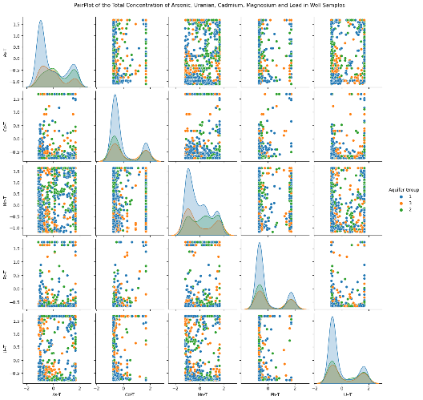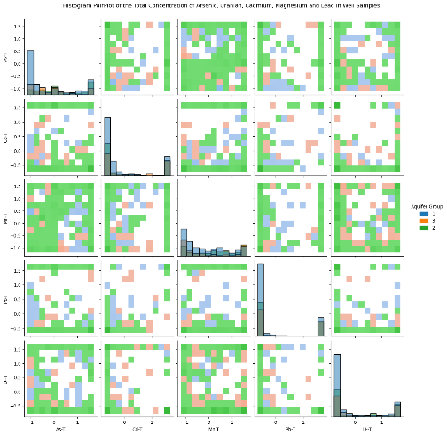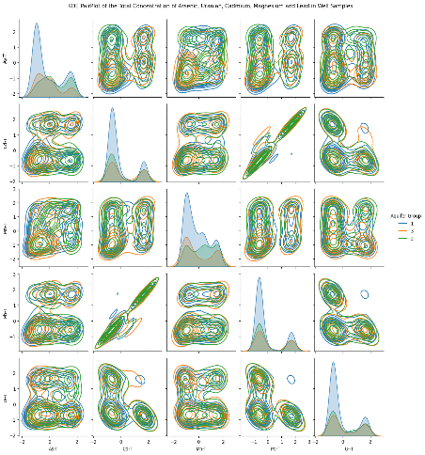
B)
C)
A)
Figure 4.1: A) From Left to right: A) pairplot, B) hisplot and C) KDE plots of the relationship between metals of interest for the full dataset.
Figure 1 shows the pair plot, histogram, and kernel density estimator (KDE)All the metals of Interest. Uranium's relationship with cadmium is seen on both the pair plot and KDE. Manganese and arsenic show no apparent pattern. A slight relationship between cadmium and lead is observed in the KDE plot and histogram plots along with manganese and cadmium.
Relationships of precipitation factors and other variables seem to display similar relationships to that showing with the correlation plots (Section 9.2 Appendix). There are no notable differences between the drought, flood, maximum temperature, or rising minimum temperature in comparison to the entire data set. Lesser or greater variations of the same pattern are shown. Heat maps show increasing temperature/ temperature differences, somewhat decreasing precipitation/precipitation differences and increasing turbidity over the years per well location (Section 9.2 Appendix).

Saltwater Intrusion Exploratory Data Analysis
Section 9.3, Appendix shows various combinations of different saltwater intrusion cutoffs and the resultant data points, Metals of Interest and saltwater intrusion factors. From this, the best data set can be found by using the cutoff for chloride of 150 μg/L or a specific conductance of 1,000 S/cm (British Columbia Ministry of Forest, 2016). This gives a data set of 106 points that has no uranium over limits, few manganese over limit and few lead over limit. However, 71 of 81 samples of arsenic in the total data set also appeared in the saltwater intrusion dataset with these criteria.
Table 7 (Section 9.3, Appendix) shows the metals above Canadian Drinking Water Standards with saltwater intrusion. A high amount of arsenic above CDWS occurs in the data set with chloride or specific conductance over saltwater intrusion limits, but not in the data set with both specific conductance over the saltwater intrusion cutoff. Arsenic is highly influenced by saltwater intrusion which causes competitive desorption and favors the biochemical reduction of As (Yuan et al., 2023). The lack of Kendall’s or Pearson’s correlation previously may be due to the smaller dataset.
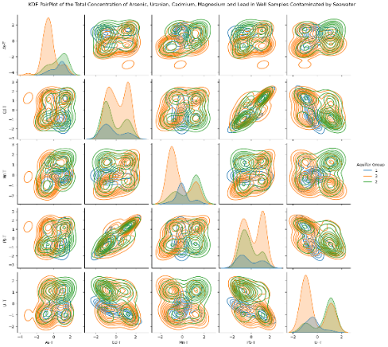
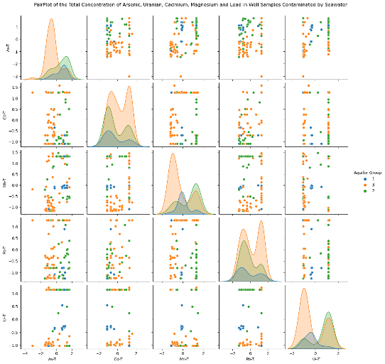
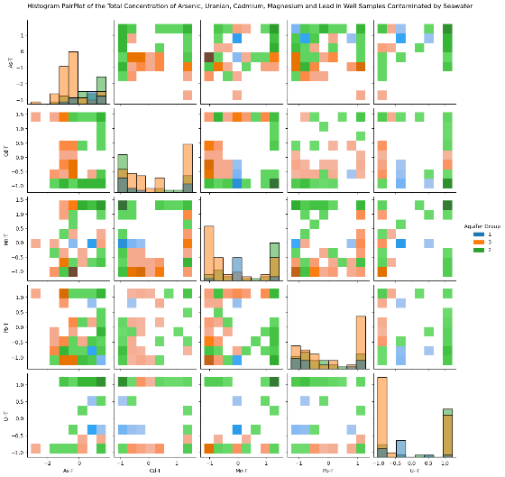
A)
B)
C)

Figure 4.2: A) From Left to right: A) pairplot, B) hisplot and C) KDE plots of the relationship between metals of interest for SWI dataset where specfic conductance ≥ 1000 or chloride ≥ 150 μg/L.
Figure 4.2 shows the relationship between different metals with saltwater intrusion for each aquifer group. Some of the weak previous correlations are shown between uranium and lead. It also illustrates that a lot of the aquifer types with saltwater intrusion are Aquifer Group 2. This could be due to previous trapped seawater or other rock water interactions (Saberimehr et al., 2017). Figures in the Appendix show expected or undetermined relationships for seawater intrusion variables, temperature and precipitation variables and all other variables (Section 9.3, Appendix)

Further Description of British Columbia



